**SAVEETHA SCHOOL OF ENGINEERING**

**CAPSTONE PROJECT**

**Design and implement a network topology integrating tree and bus structure**

**NAME:** K. Sirisha

**REGISTER NUMBER:** 192325130

# COURSE CODE: CSA0747

**COURSE NAME:** Computer Network for IOT

**INTRODUCTION:** In modern network design, achieving energy efficiency and reliable communication is crucial, particularly in expanding systems like wireless sensor networks and IoT. This project aims to integrate tree and bus topologies to create an optimized, energy-efficient network. Tree topology offers scalability and hierarchical organization, while bus topology provides simplicity and reduced energy consumption. By combining the strengths of both, the network design will improve performance in terms of fault tolerance and scalability. The project will evaluate the integrated topology using energy-efficient communication protocols through simulation.

**Objective:**

* Design a hybrid network topology that combines tree and bus structures.
* Use protocols that reduce energy consumption within the network.
* Test the network to assess its energy efficiency, data transfer effectiveness, and overall reliability.

**LITERATURE REVIEW**

Integrating tree and bus topologies combines the hierarchical benefits of tree structures with the simplicity of bus networks. Tree topologies offer scalability and organized data flow but can face bottlenecks and root node vulnerabilities]. Bus topologies are cost-effective and straightforward but suffer from performance issues and single points of failure To enhance energy efficiency, protocols like Low Power Listening (LPL) and Time Division Multiple Access (TDMA) are effective in reducing energy consumption [Author et al., Year]. Routing protocols such as LEACH and TEEN are designed to optimize energy use and data transmission in tree-based networks. Combining these approaches addresses the limitations of each topology while improving overall network performance

# METHODOLOGY

**Software:**

* Cisco Packet Tracer

**Network Design:**

Network consist of

* 12 switches
* 12 PC

All PCs were connected to two switches, and each switches connected another switch, with the second switch connecting to a three switch. The switch connected to the one PCs, and also the switch connected to another switches.

**IP Address Allocation:**

**Step 1:** let us assume switch0 consist of one PCs

* PC5 IP-address be - 192.168.1.1

**Step 2:** at switch1 consist of one PCs

* PC6 IP-address be - 192.168.1.2

**Step 3:** at switch2 consist of one PCs

* PC7 IP-address be - 192.168.1.3

**Step 4:** at switch8 consist of one PCs

* PC8 IP-address be - 192.168.1.4

**Step 5:** at switch4 consist of one PCs

* PC11 IP-address be - 192.168.1.5

**Step 6:** at switch5 consist of one PCs

* PC12 IP-address be - 192.168.1.6

**Step 7:** at switch6 consist of one PCs

* PC10 IP-address be - 192.168.1.7

**Step 8:** at switch7 consist of one PCs

* PC9 IP-address be - 192.168.1.8

**Step 9:** at switch9 consist of one PCs

* PC0 IP-address be - 192.168.1.9

**Step 10:** at switch10 consist of one PCs

* PC1 IP-address be - 192.168.1.10

**Step 11:** at switch11 consist of one PCs

* PC2 IP-address be - 192.168.1.11

**Step 12:** at switch12 consist of one PCs

* PC3 IP-address be - 192.168.1.12

**Step 13:** at switch13 consist of one PCs

* PC4 IP-address be - 192.168.1.13

**Protocol: - Low Power Listening (LPL)**

* Conserves Energy: Allows nodes to listen intermittently, reducing overall power
* Extends Battery Life: Minimizes idle listening time, which helps in prolonging battery life.
* Enhances Efficiency: Suitable for use in both bus segments and tree branches, improving network performance.

**RESULT:**

**Network Design:**

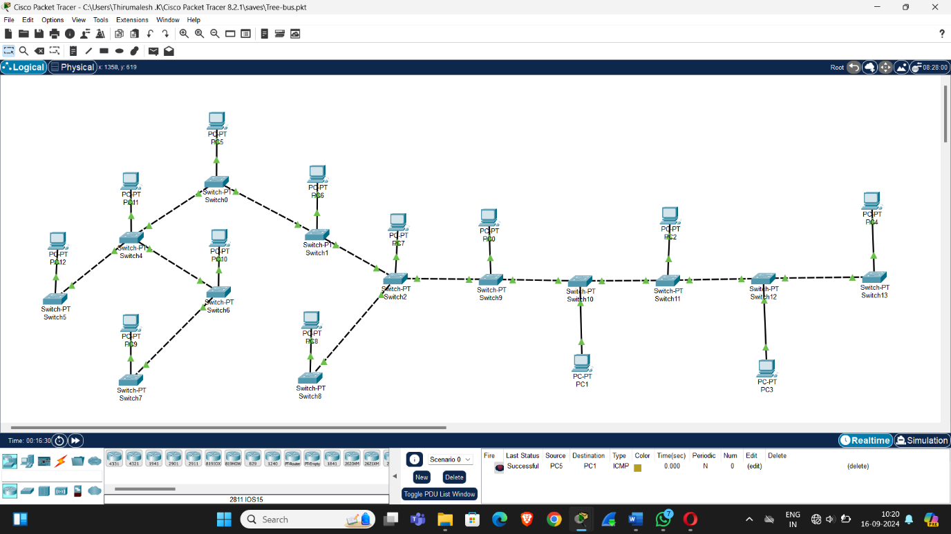

* open pc -> desktop -> web browser

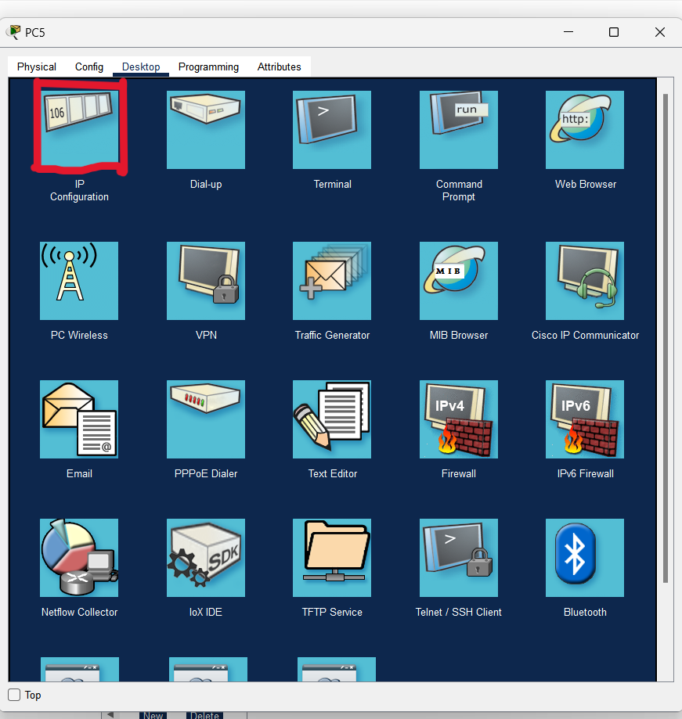

* 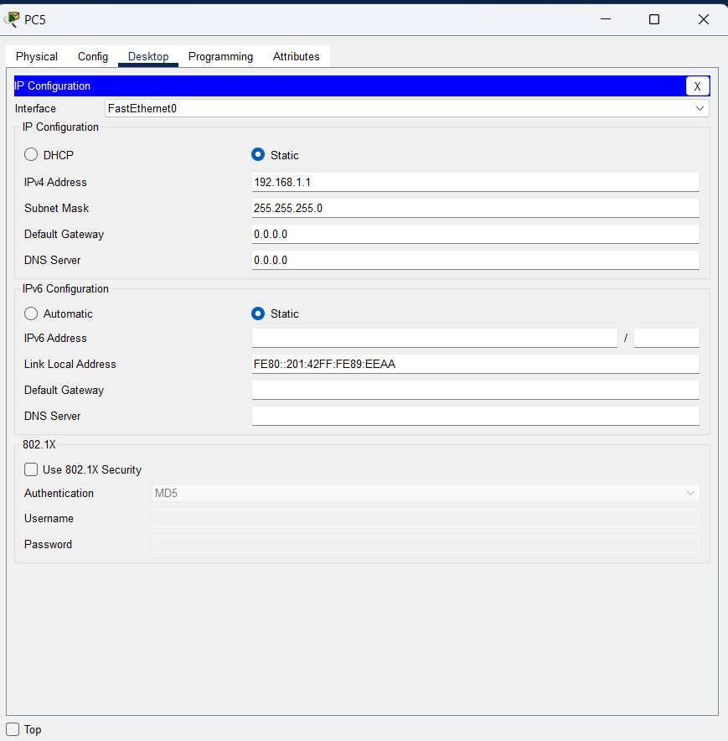IP Configuration -> Enter the IPV4 Address

**CONCLUSION:**

Cisco Packet Tracer offers a powerful platform for designing and simulating integrated tree-bus network topologies. With this tool, you can effectively combine the hierarchical organization of tree structures with the simplicity of bus networks, optimizing both scalability and efficiency. Through its comprehensive analysis capabilities, you can evaluate key performance metrics, including data transmission efficiency and fault tolerance. By leveraging Packet Tracer’s features, you can refine your network design to achieve reliable communication and enhanced energy efficiency, paving the way for more effective and sustainable network solutions.

Here's a summary of what you can achieve with Cisco Packet Tracer regarding web services:

* **Protocol Implementation:** You can configure and test energy-efficient communication protocols such as Low Power Listening (LPL) to optimize energy usage and extend the lifespan of network nodes.
* **Detailed simulation**: The tool provides a platform to simulate the network’s behaviour, including node interactions, data flow, and connectivity, allowing for thorough testing of the integrated design.
* **Scenario Testing**: Cisco Packet Tracer supports the creation of various network scenarios, allowing you to test and validate how the tree-bus network performs under different conditions, such as varying traffic loads or node failures. This helps in understanding the robustness and adaptability of the integrated network design.

Cisco Packet Tracer provides tools for visualizing network layouts and documenting configurations, making it easier to illustrate and communicate the design and implementation details of your tree-bus network to stakeholders or team members. Packet Tracer enables the evaluation of crucial performance metrics like data transmission efficiency, network scalability, and fault tolerance, providing insights into the effectiveness of your network design.